GPR Root Mapping System

Pre-Proposal

11/25/15

ECEN 403 – Capstone (Senior) Design

Texas A&M University, College Station, TX

Team 24

Tyler Castro

Daniel Miller

.

Abstract

The goal of this project is to create a ground penetrating radar system to serve as a non-destructive method for mapping plant root systems. The system consists of two antennas, one for receiving and one for transmitting, a control unit and power supply.

A control unit will be used to pass an electrical pulse to an antenna. The antenna will transmit the signal into the ground at a frequency of 915 MHz. The signal will reflect off materials with different dielectric constants like that of roots and pipes. The strength and time required for the return of any reflected signal is measured and recorded.

This data is collected over a given area and a computer, using specialized software, will apply mathematical functions to the signal in order to remove background interferences. The software will display the strength of the reflected signal with respect to time and position in a 2-D image.

Power being delivered to the antennas must be regulated to allow the generating antenna to propagate radio waves with high enough energy to overcome the attenuation that happens as the wave travels through the ground. Output power is to be regulated according to the type of soil being penetrated, as well as the plant type to be mapped.

# INTRODUCTION

A. Need Statement

Root growth is complex and little is known about the reason behind root development patterns. Better understanding roots will offer deeper insight into water and nutrient flow in an ecosystem, but observing root growth in an ecosystem over a period of time can be difficult, and no good non-destructive methods are in place. A ground penetrating radar system allows for the observation of root growth while preserving the wellbeing of the ecosystem.

B. Proposed System

The ground penetrating radar system can be broken down into four subsystems as shown in Figure 1: Power, Control Unit, Antennas, and Signal processing/Display.

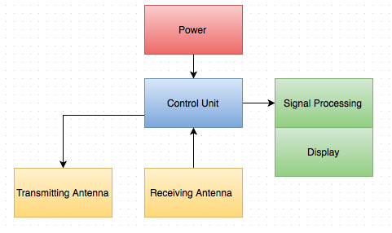

Fig. 1. System block diagram

The ground penetrating radar system depicted in Figure 2 works by using antennas to send an electrical pulse into the ground and record the strength and the time required for the return of any reflected signal. Reflections are produced when radio waves pass through materials with different electrical conductivity; some of the original signal is reflected while some continues to travel in the material until it reaches another boundary where more of the signal is reflected or until the signal dissipates. These reflected signals are collected using another antenna and passed into a digital processor that will create a 2-D image using mathematical functions.

Contrary to most ground penetrating systems, we chose to use phased array antennas at a frequency of 915MHz. A phased array antenna is exactly what it sounds like, an array of antennas spaced half a wavelength apart. If the antenna is designed correctly, by passing the signal through all antennas at the same time, the sinusoidal waves produced will constructively and destructively interact with each other so that a single wave will travel in the desired direction and cancel each other out in all other undesired directions. This will help to reduce noise in the receiving antenna.

This frequency was selected because of the high resolution needed to detect plant roots. Low frequencies (1-500MHz) are used in ground penetrating radar systems where a large depth of penetration is required. Higher frequencies have lower penetration depths because more of the signal is reflected off boundaries between different dielectric properties like that of roots. We chose this frequency because of its depth of .7 meters, which is the optimum depth to observe root growth.



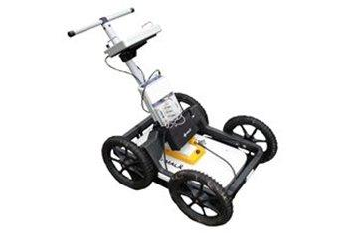









Fig. 2. Physical Sketch of the System

1. CONCEPTUAL DESIGN DESCRIPTION
2. Implementation

**Transmitting Antenna**

The design of the transmitting antenna is shown below in Figure 3. The coaxial oscillator will be connected to a switch, which will be controlled by the microcontroller. The microcontroller can be programmed to control the pulse repetition frequency and pulse duration by completing the circuit for a period of time. A pulse from the oscillator will pass through an attenuator and a power amplifier before being sent through the antenna array. The attenuator helps with impedance matching with the antenna, and will lower the Voltage Standing Wave Ratio in order to have minimal power reflection when fed to the antenna. The low noise power amplifier will increase the power of the pulse passed through it, which will give the pulse a large signal-to-noise ratio, allowing for clearer images to be created after signal processing. Before reaching the antenna, the pulse will also go through a power splitter. The splitter will branch the pulse with minimal insertion loss, so the pulse can then also be sent to the receiving end of the antenna system for signal mixing.

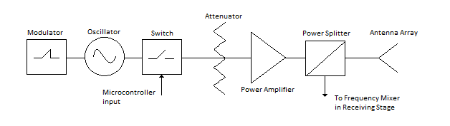

**Figure 3: Transmitting Antenna design**

The modulator shown in figure 3 is used to implement frequency modulation for pulse compression, as explained in the following section.

**Pulse Compression**

Pulse compression will also be implemented in our system design, which will increase range resolution and signal to noise ratio, and allow us to balance pulse duration and consumed power. Pulse compression can be achieved through either frequency modulation, or phase modulation [1].

For frequency modulation, our input pulses can be modified to have a frequency that changes linearly over the period of the pulse. This type of signal is referred to as a linear chirp. When the received chirp is intercorrelated with our original chirp, the resulting signal has a smaller width than the original. This improves our resolution, because received signals that are shorter in time mean that reflections can be closer together without blending together. A visual example of frequency modulated pulse compression is shown in figure 4. In order to change our input pulses to chirps, a modulator can be inserted, which will produce a linear ramp function. This ramp function will be fed into the Vtune input pin of the oscillator, which will cause the input voltage to be proportional to the transmit frequency, creating linear chirps.

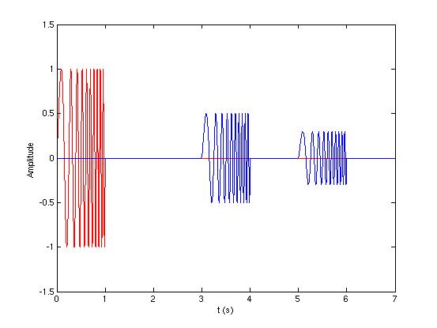 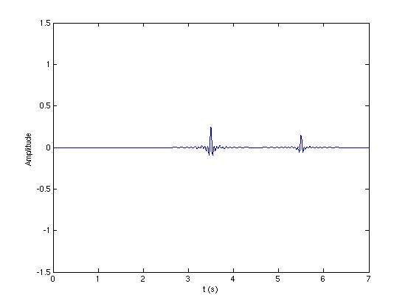

**Figure 4: Linear chirp with two reflections, and the resulting echos from matched filtering [2]**

For phase modulation, the input pulse can be modified to be broken up into a series of time slots with equal duration. These slots can be assigned a phase of either 0 or 180 degrees. There are sequences of phases that, when correlated with itself, create a resulting pulse with large sidelobe level ratios. For example, taking the original pulse and splitting it into two, with the first half of the pulse having a phase of 180 degrees and the second half having a phase of 0 degrees, relates to the Barker code of +1, -1. Correlating that pulse with itself creates a pulse with sidelobe level ratios of -6 dB. To create this example in our circuit, another switch could be inserted to direct the first half of the pulse through a phase shifter of 180 degrees, then switch to another line without the phase shifter for the second half of the pulse. However, this will be difficult to achieve, as the speed of the switch would have to be impossibly fast.

**Phased Antenna Array**

With an antenna array, phase shift modules can be used to alter the phase of individual antennas and direct the total radiation pattern and direction of the system. For the proposed system, the array’s total radiation pattern can be directed to focus on a specific point to increase the total energy of radiation. This would be helpful for when the ground has high water concentration and attenuates RF waves greatly.

A passive phased array, where there is a single source of RF waves and a phase shift module for each antenna in the array, would be the easiest implementation. A block diagram of a passive phased array is shown in figure 6. Due to destructive and constructive interference, an array of antennas has a high gain width, and low sidelobes, with the gain centered in the middle of the array. The direction of the main lobe can be altered using the phase shifters.

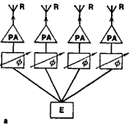

**Figure 6: A general representation of a passive 4 antenna phase array [3]**

**Antenna Choice**

Because we only need the pulse directed in a specific area, directional antennas were looked into for use in this project, as opposed to omnidirectional antennas. After researching previously used antennas in similar projects, the horn antenna seemed to be the most used type of antenna for GPR. Because horn antennas have no resonant elements, they have a wide bandwidth, and have high antenna gain [4]. However, they are not easily constructed, and are more expensive than antennas of more simple design. The Vivaldi antenna co-planar directional antenna with a wide bandwidth. Vivaldi antennas are of simple design, making them low-cost. Their combination of efficiency in both performance and price makes Vivaldi antennas the choice for this project. A simple diagram of a Vivaldi antenna is shown in figure 7.

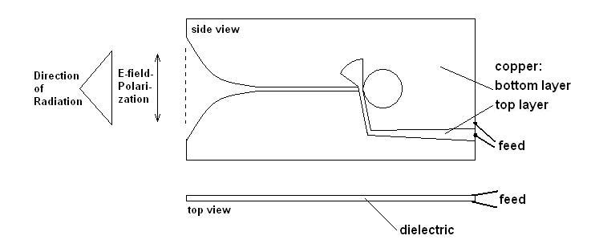

**Figure 7: A Vivaldi Antenna**

1. Analysis

**Penetration depth**

Penetration depth of microwave and RF power is defined as the depth where the power is reduced to 1/e or 36.7% (e=2.718) of the power entering the surface [5]. The penetration depth of a signal as a function of frequency is shown below (1). Using a frequency of 915 MHz and a complex relative permittivity of sand at 20% moisture content with ε*= 20.3 􏰁- j1.17 [1], the penetration depth was calculated to be .201 meters. Another calculation of penetration depth was done for sand with a moisture content of 4% which resulted in a penetration depth of .733 meters. This shows that moisture content is a large factor in calculating penetration depths and determining the moisture content of the soil before scanning is important. Note: this calculation only shows penetration depths meaning once the signal reflects off an object the signal will then experience an equivalent loss traveling back to the receiving antenna. For this reason, a high power signal must be sent so that the signal can travel to these depths and return with enough power for the antenna to receive.

$dp=\frac{c}{2Πf\sqrt{2ε'(\sqrt{1+(\frac{ε''}{ε'})^{2}}-1)}}$ (1)

$.201≅\frac{3E8}{2Π(915E6)\sqrt{2(20.3)(\sqrt{1+(\frac{1.17}{20.3})^{2}}-1)} }$ (20% MC) (1)

$.733≅\frac{3E8}{2Π(915E6)\sqrt{2(3.33)(\sqrt{1+(\frac{.13}{3.33})^{2}}-1)}}$ (4% MC) (1)

# 

# 

# 

# 

# 

# 

# 

# 

# **References**

[1] C. Allen , “Radar Pulse Compression ,” 2004. [Online]. Available at: https://www.ittc.ku.edu/workshops/Summer2004Lectures/Radar_Pulse_Compression.pdf. [Accessed: 2015]

[2] Flambe , "Chirp before" and “Chirp compr” 2006. [Online]. Available at: https://commons.wikimedia.org/wiki/File:Chirp_before.jpg#/media/File:Chirp_before.jpg and https://commons.wikimedia.org/wiki/File:Chirp_compr.jpg#/media/File:Chirp_compr.jpg. [Accessed: 2015]

[3] “Phased Array” 2003. [Online.] Available at: http://encyclopedia2.thefreedictionary.com/Phased+array+radar. [Accessed: 2015].

[4] “The Horn Antenna” 2009. [Online.] Available at: http://www.antenna-theory.com/antennas/aperture/horn.php. [Accessed: 2015].

[5] V. Komarov, S. Wang, and J. Tang , “Permittivity and Measurements ,” 2005. [Online]. Available at: http://public.wsu.edu/~sjwang/dp-rf-mw.pdf. [Accessed: 2015].